**Assignment Date : 13-09-2022**

**Name : SRAVANI T**

**Reg No : 111519106153**

**Maximum Marks : 2 Marks**

**Question**

**CREATE CIRCUIT WITH PIEZO ALARM,PIR SENSOR,TMP SENSOR WITH BELOW FUNCTIONALITIES:**

**1. ALARM SHOULD SOUND IN ONE MANNER IF TEMP IS ABOVE 60 C**

**2. ALARM SHOULD SOUND WITH ANOTHER FREQUWNCY IF MOTION IS DETECTED IN PIR SENSOR.**

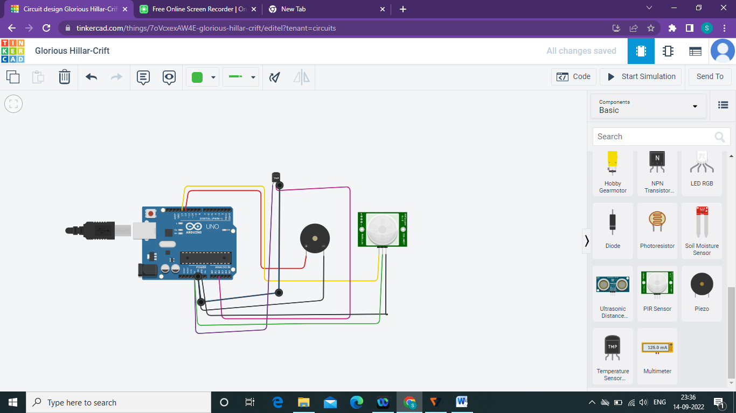

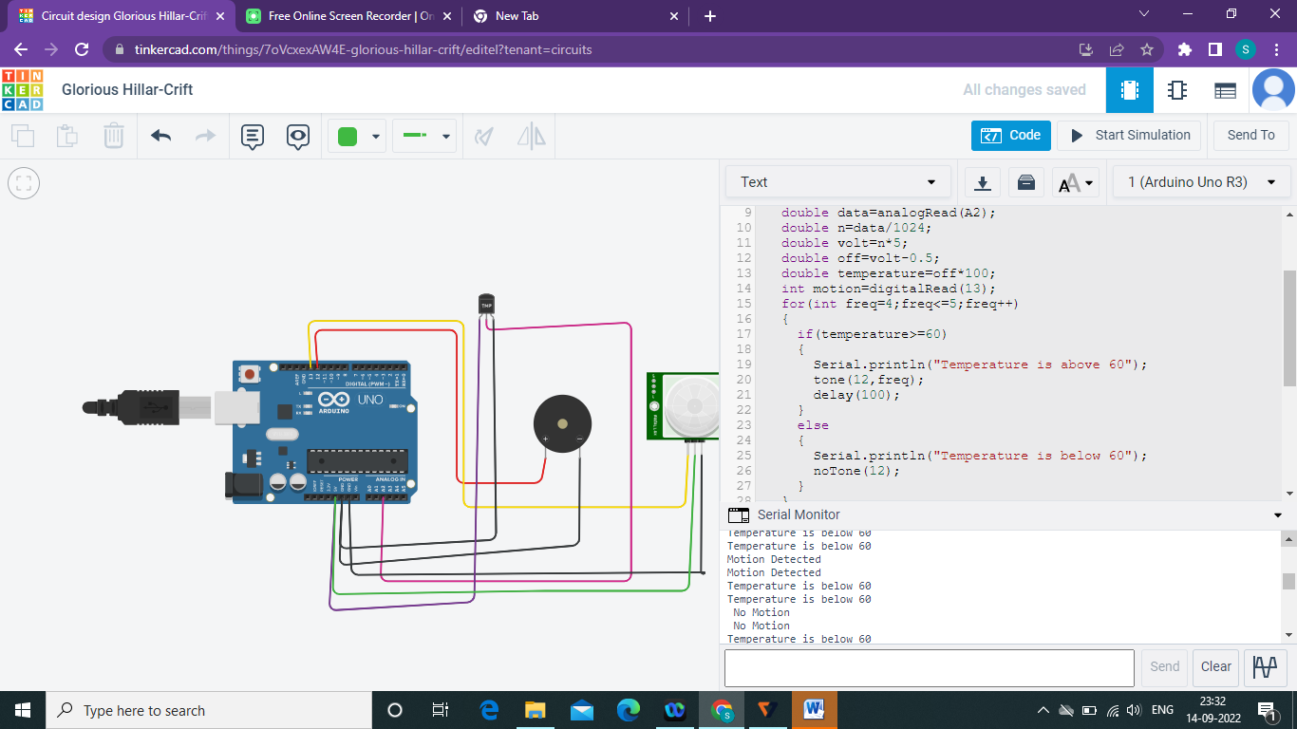

**CODE:**

void setup()

{

Serial.begin(9600);

pinMode(13,INPUT);

pinMode(12,OUTPUT);

}

void loop()

{

double data=analogRead(A2);

double n=data/1024;

double volt=n*5;

double off=volt-0.5;

double temperature=off*100;

int motion=digitalRead(13);

for(intfreq=4;freq<=5;freq++)

{

if(temperature>=60)

{

Serial.println("Temperature is above 60");

tone(12,freq);

delay(100);

}

else

{

Serial.println("Temperature is below 60");

noTone(12);

}

}

for(intfreq=2;freq<=3;freq++)

{

if(motion==1)

{

Serial.println("Motion Detected");

tone(12,freq);

delay(200);

}

else

{

Serial.println(" No Motion");

noTone(12);

}

}

}